Caesar Cipher

<https://www.dcode.fr/caesar-cipher>

<https://planetcalc.com/1434/>

Polyalphabetic Cipher

<https://www.dcode.fr/vigenere-cipher>

Playfair Ciphers (加密使用right below sameline 解密使用left above sameline)

<https://www.dcode.fr/playfair-cipher>

Row Transposition Ciphers

<https://www.dcode.fr/transposition-cipher>

Monoalphabetic Cipher

<https://www.dcode.fr/monoalphabetic-substitution>

XOR

<https://codebeautify.org/xor-calculator>

Mod 直接Google： 例如 10^5 mod 35

<https://www.mtholyoke.edu/courses/quenell/s2003/ma139/js/powermod.html>

Vigenère Cipher

<https://www.dcode.fr/vigenere-cipher>

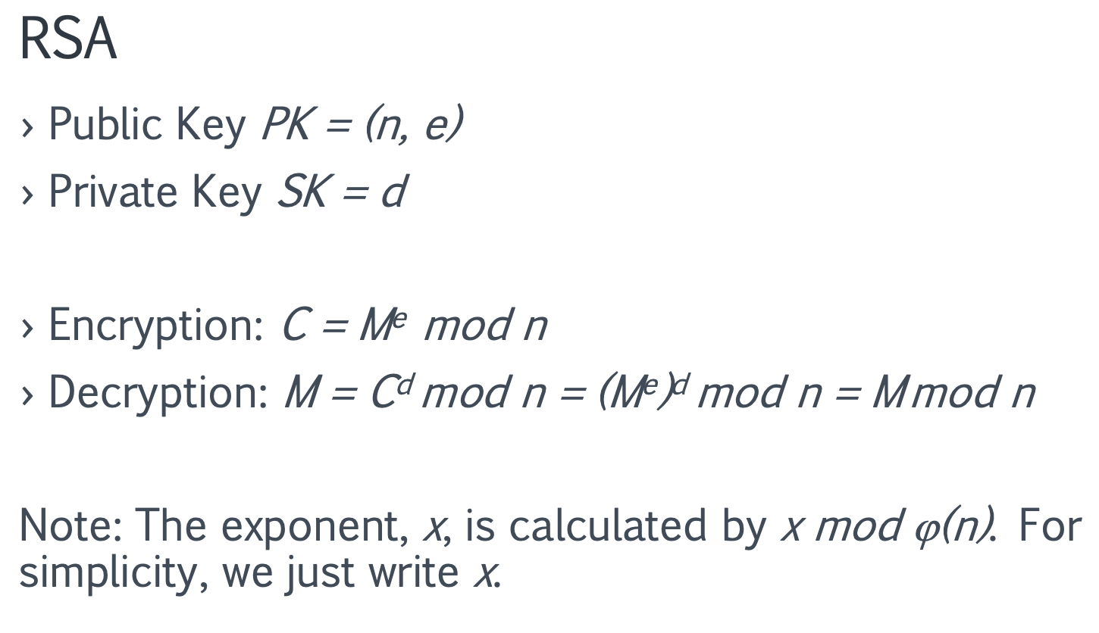

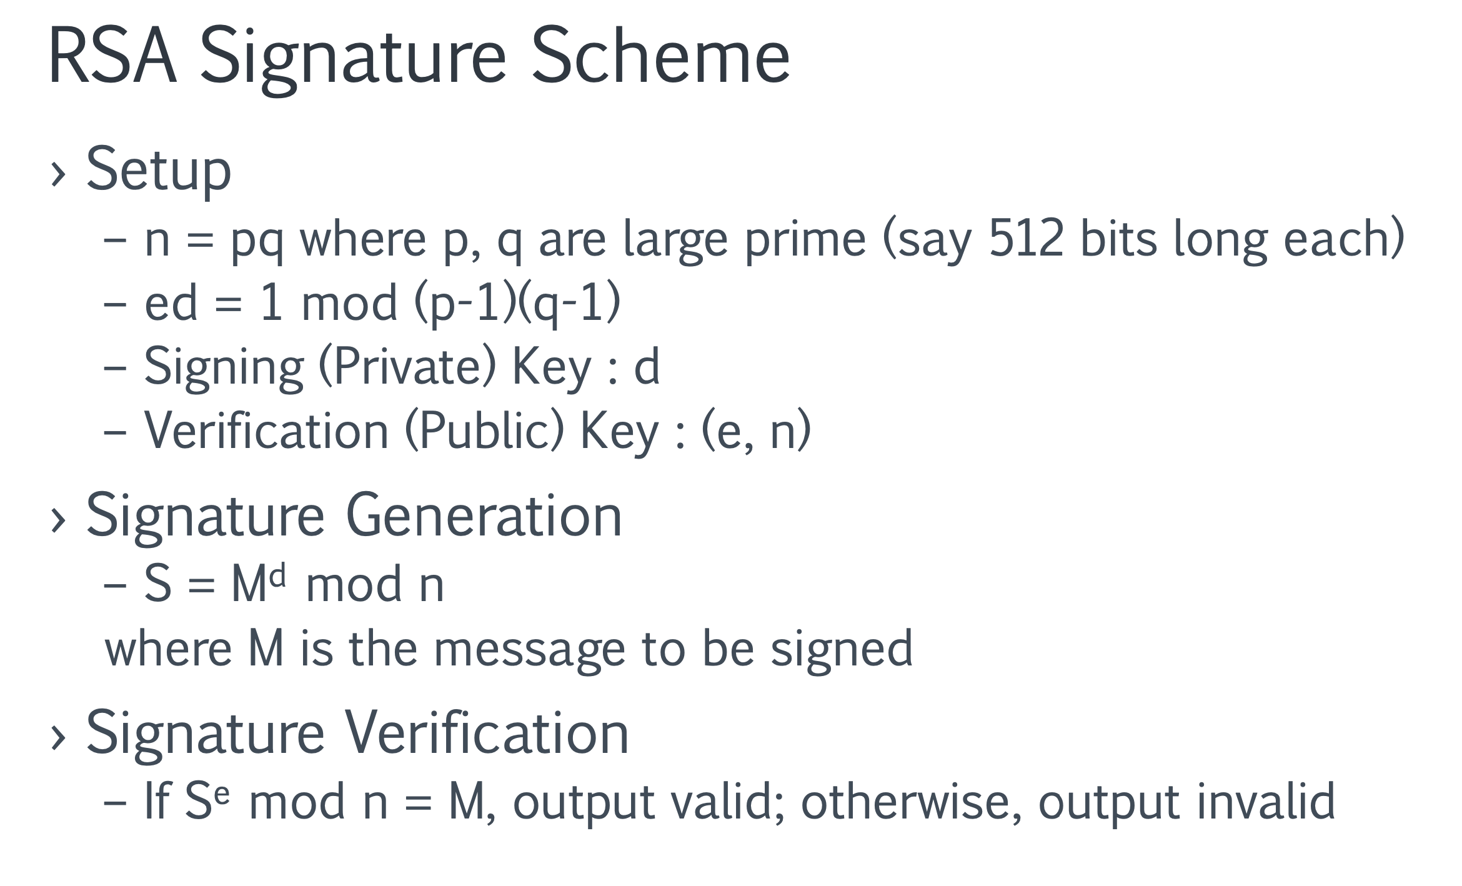

**2019 - 2020**

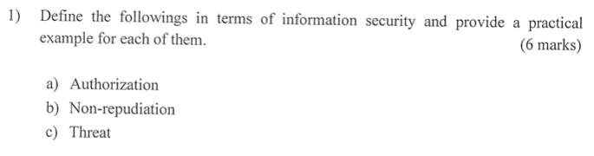

A threat is a potential violation of security.

Authentication is the process of validating a user's identity to grant them access to a system or network.

Nonrepudiation is the assurance that someone cannot deny something. In a general information security context, assurance that the sender of information is provided with proof of delivery, and the recipient is provided with proof of the sender's identity, so neither can later deny having process the information.

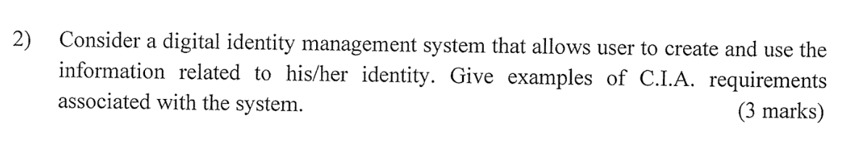

Confidentiality: the identity system should keep the information secret and do not let people know other one’s information.

Integrity: nobody is allowed to make any illegal change to the information.

Availability: the users can use the information whenever they want. There should be no denial of service.



Designers of policies always make the assumption that the security mechanisms prevent the system from entering a “non-secure” state. Security rests on assumptions. If the assumption is erroneous, the system will be non- secure.

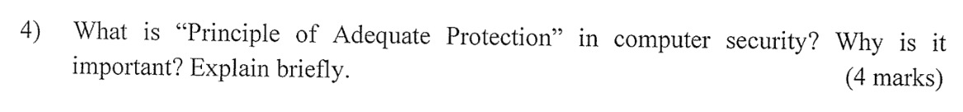

Items should only be protected while they are valuable, and that the level of protection should be consistent with their value. It is important because there is always a cost for setting up a protection.

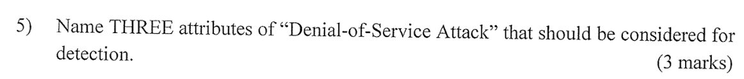

The maximum number of requests allowed per second to the target server and the threshold is protocol specific.

The maximum number of requests allowed per second to the target server per client.

The maximum number of partial requests allowed per second to the target server and the threshold is protocol specific.

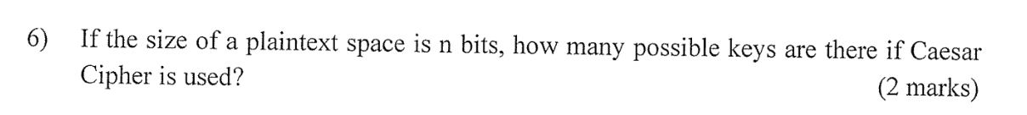

n

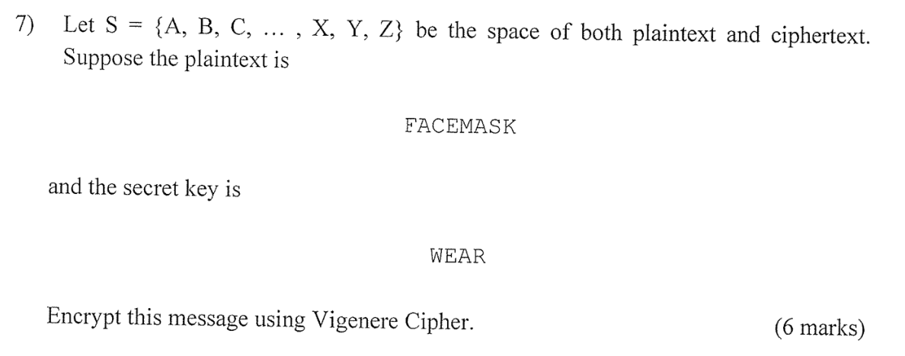

BECVIESB



Unbreakable since ciphertext bears no statistical relationship to the plaintext. Otherwise we may get some information or pattern from the ciphertext.

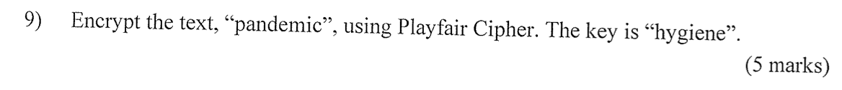

QNANIOCM

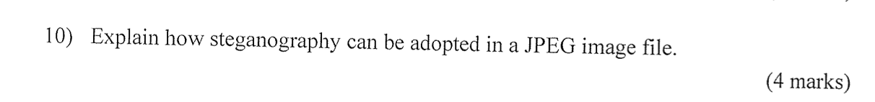

Each pixel is represented in hex. There is a field (after FFDB0043) which can be used to store some text.



18695



If we want to know plaintext M, we should know d, if we want to know d, we should know phi n; if we want to know phi n, we should know p and q. However, get p and q from n is hard. If it is easy, then we can easily decrypt the ciphertext.



Setup

– n = pq where p and q are large prime (say 512 bits long each)

– ed = 1 mod (p-1) (q-1)

– Signing (Private) Key: d

– Verification (Public) Key: (e, n)

Signature Generation

–S=M^d mod n

where M is the message to be signed

Signature Verification

– If S^e mod n = M, output valid; otherwise, output invalid



Partition the input message into fixed-sized blocks. › E.g., 512 bits per block. The remaining bits of the input are padded with the value of the message length. Can use block ciphers as hash functions. Set the initial value of IV as 0s and use DES to cipher block by block. Finally, we use the final block as the hash value.

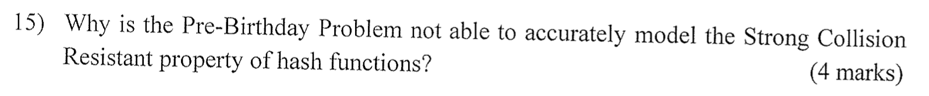

Because we should compare every pair of X and Y.



Anyone can compute Ki, given Ki-1 and Let H be a one-way hash function.

Setup:

Alice sends KN to Bob.

Bob initializes the database entry.

Authentication:

Alice sends KN-1 to Bob.

Bob checks if KN = H(KN-1).

If yes, Bob stores KN-1 and discards KN.

The storage complexity of Bob is O(1) since only one key has to be stored at any moments.

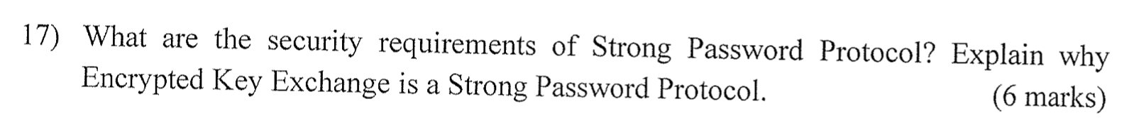

Strong password protocol:

– Secure against eavesdropper: No available plaintext-ciphertext pairs for dictionary attack.

– Secure against impersonation: Malice must guess the correct W in order to impersonate Bob in the first message flow.

So, it achieves mutual authentication: Bob must know W to encrypt PKE(K) correctly. Alice must know W (and her private key) to recover K and use K to encrypt RA correctly



Handshake Protocol is responsible for the authentication and key exchange necessary to establish secure sessions. Handshake Protocol manages the following:

– Cipher suite negotiation

– Authentication of the server and optionally, the client – Session key information exchange



There are cases when a certificate has to be made invalid before its expiry date. The CA should periodically, or on demand basis, distribute CRL (which is signed by the CA) listing the serial numbers of the certificates that have been revoked. A participant using a certificate should check the latest CRL from the CA, to determine if the certificate is still valid.

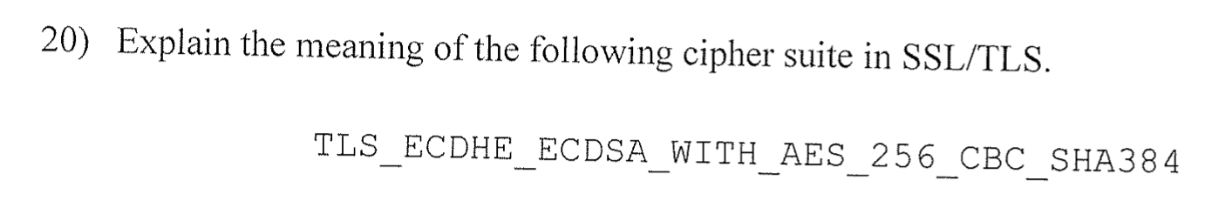

Protocol:

Transport Layer Security (TLS)

Key Exchange:

Elliptic Curve Diffie-Hellman Ephemeral (ECDHE)

Authentication:

Rivest Shamir Adleman algorithm (RSA)

Encryption:

Advanced Encryption Standard with 256bit key in Cipher Block Chaining mode (AES 256 CBC)

Hash:

Secure Hash Algorithm 384 (SHA384)

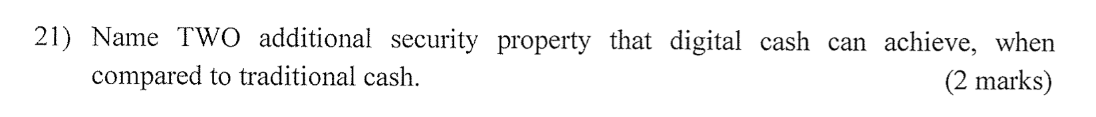

– Can pay for any value (up to certain limit)

– Easy to convert from traditional bank notational money

› download and upload values with user’s bank account – Infeasible to forge

– Payer untraceable by PSP (Payment Service Provider)

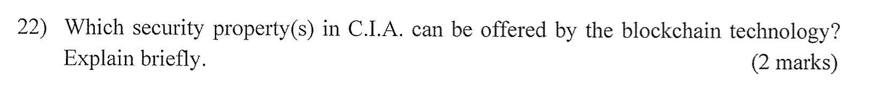

Integrity and availability; All data stored as transactions in the blocks are signed which provides a high level of Integrity protection. Changes to the data in a block are also nearly impossible due to the use of linking via hashes, and the consensus requirement. Also, since a distributed architecture is used, a high level of Availability is provided by design since a full copy of the data resides across several nodes. Confidentiality on the other hand is typically low by default, since blockchain requires the ability of the transaction data to be visible and verifiable by design.

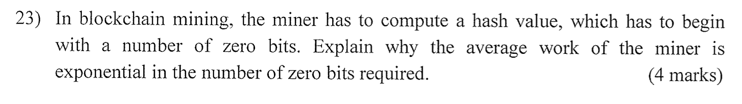

The key point is that each nonce generates a basically random hash value. To get a lot of zeroes, you need to try an exponentially large number of nonces. Adding more zeroes (more precisely as a prefix) to the required block hash (which is the hash of block header) makes it more difficult because you need to keep hashing the block header until you find a hash value. For example, to find 000 from 000 to 999 is with chance 1/1000, but to find 0000 from 0000-9999 is 1/10000.

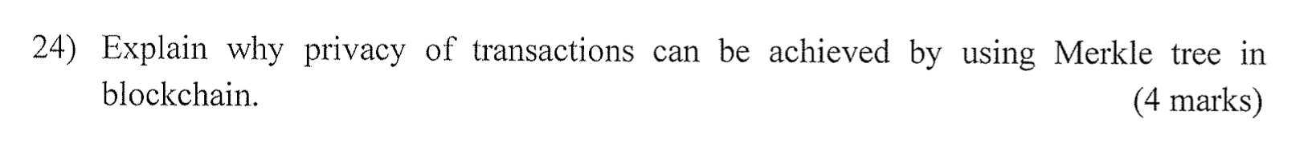

It generates a hash value for each transaction. For hashes of all transactions in a block, generate only a single hash. Thanks to the one-way and weak collision resistant properties of hash functions, we can be assured that the transaction data are not tempered.

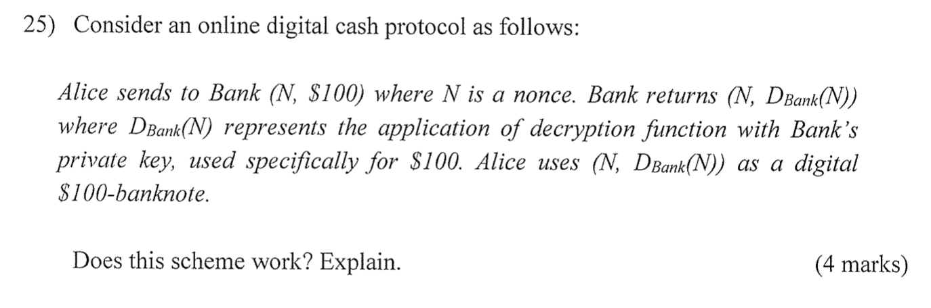

It works. But it is traceable.

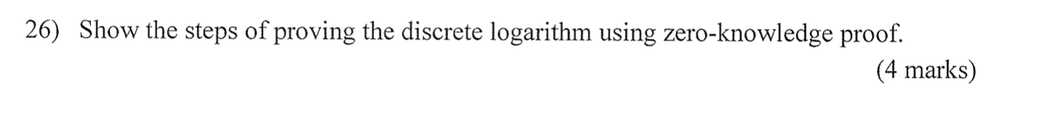

**2018-2019**





Repudiation of origin, a false denial that an entity sent (or created) something, is a form of deception. For example, suppose a customer sends a letter to a vendor agreeing to pay a large amount of money for a product. The vendor ships the product and then demands payment. The customer denies having ordered the product and by law is therefore entitled to keep the unsolicited shipment without payment. The customer has repudiated the origin of the letter. If the vendor cannot prove that the letter came from the customer, the attack succeeds. A variant of this is denial by a user that he created specific information or entities such as files. Integrity mechanisms cope with this threat.

Denial of receipt, a false denial that an entity received some information or message, is a form of deception. Suppose a customer orders an expensive product, but the vendor demands payment before shipment. The customer pays, and the vendor ships the product. The customer then asks the vendor when he will receive the product. If the customer has already received the product, the question constitutes a denial of receipt attack. The vendor can defend against this attack only by proving that the customer did, despite his denials, receive the product. Integrity and availability mechanisms guard against these attacks.



Weaker; We should try to avoid the attack even in the worst situation.



Not practical, it needs truly random and safe exchange.

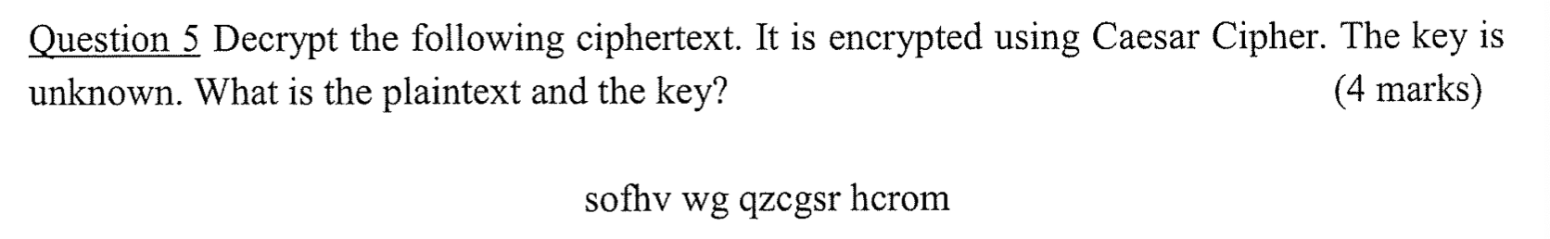

earth is closed today



Frequency attack; Its main weakness was that if the attacker intercepted two or more messages of the same length using the same key, they could be compared by a tedious process known as "multiple anagramming," finding solutions to both.

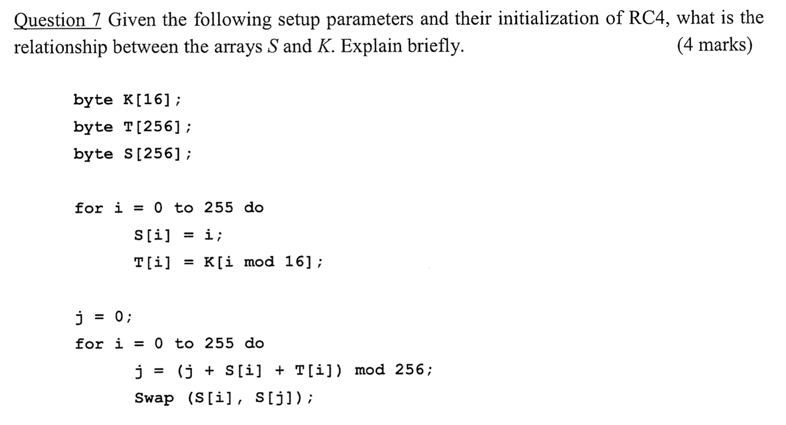



DESX is a stronger variation of the DES encryption algorithm. C=K3 XOR DES(K2,M XOR K1) We can make K1 and K3 all zeros.



Add a string 1000...0 to fill out the last block to the correct length.



CFB mode is very similar to CBC, but the primary difference is that CFB is a stream mode. It uses feedback, which is the name for chaining when used in stream modes, to destroy patterns. The main difference is that one should encrypt ciphertext data from the previous round (so not the plaintext block) and then add the output to the plaintext bits.

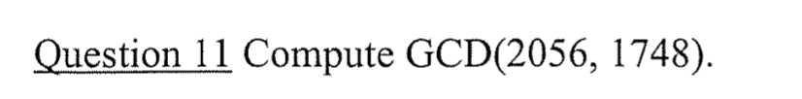

4

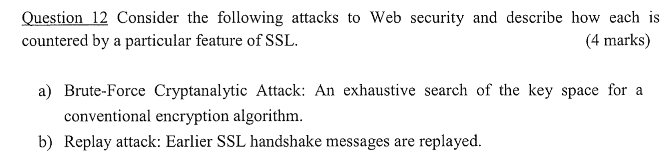

SSL protection by using secure symmetric ciphers with key lengths of at least 128

bits and up.

SSL protection by use of randomized parameters (“nonces”).

<https://dvikan.no/gamle-ntnu-eksamener/TTM4135_Informasjonssikkerhet/TTM4135eksamenvaar2004_svar.pdf>



Cross-Site Request Forgery (CSRF) is an attack that forces an end user to execute unwanted actions on a web application in which they are currently authenticated.

The referer Header and Secret Number in Cookie



?

Stack-based buffer overflows are more common, and leverage stack memory that only exists during the execution time of a function.

Heap-based attacks are harder to carry out and involve flooding the memory space allocated for a program beyond memory used for current runtime operations.

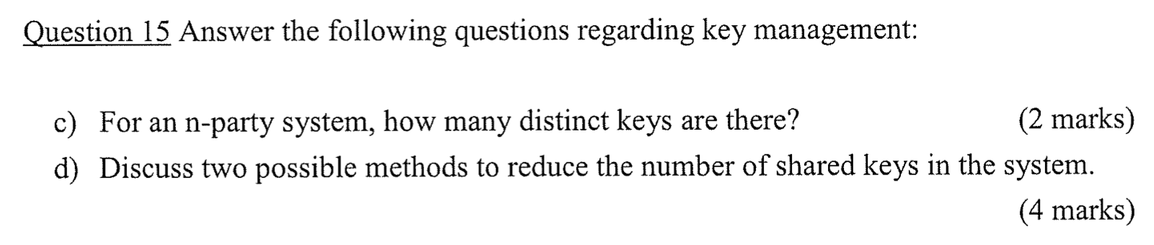

n * (n – 1) /2

Centralized system, which only need n keys. / public keys

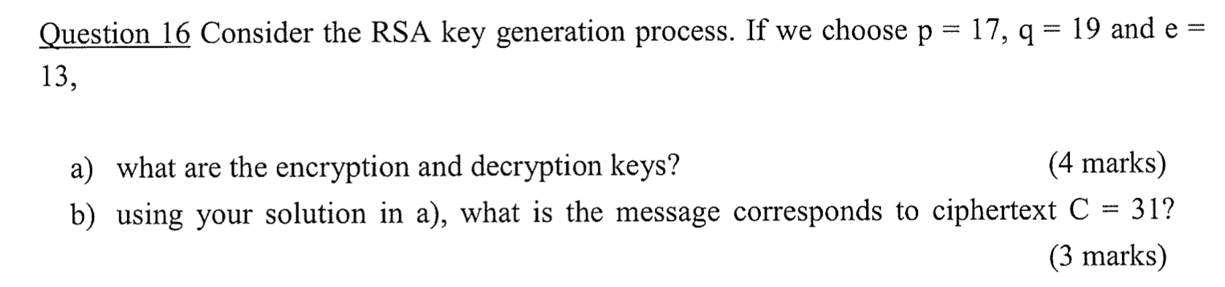

encryption: n = pq = 323, e = 13,

phi_n = 288

d = 133

M = C ^ d mod n = 12

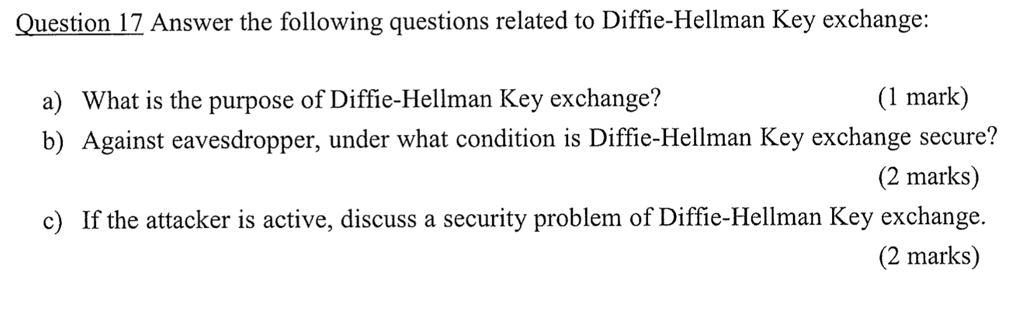

The main purpose of the Diffie-Hellman key exchange is to securely develop shared secrets that can be used to derive keys.

This key exchange scheme is secure against eavesdroppers if Diffie-Hellman Problem is assumed to be hard to solve (DLP is HARD).

However, it is insecure if the attacker in the network is active: man-in-the-middle attack.

– “Active” means that the attacker can intercept, modify, remove or insert messages into the network.

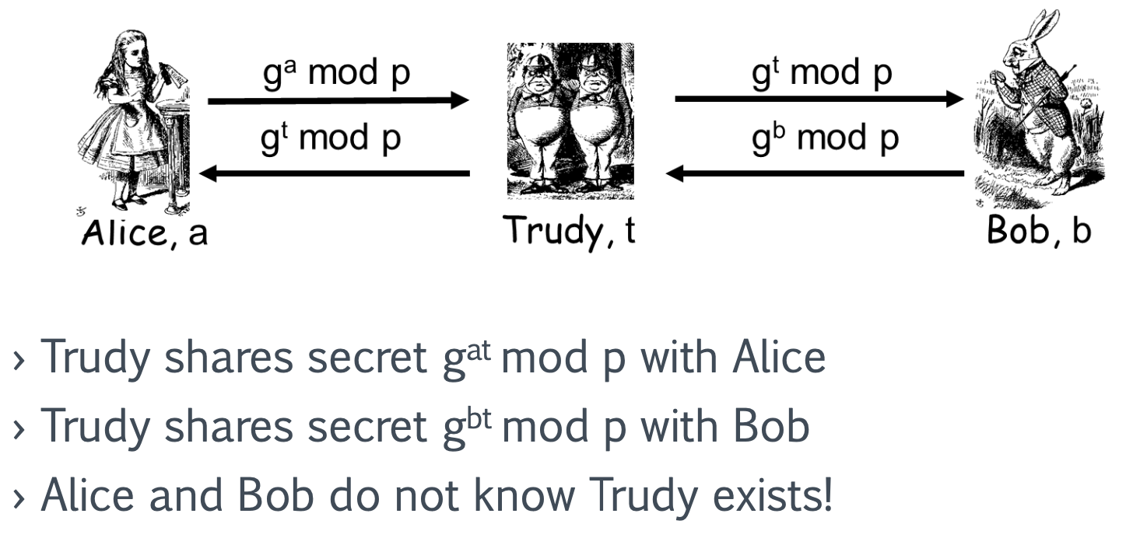

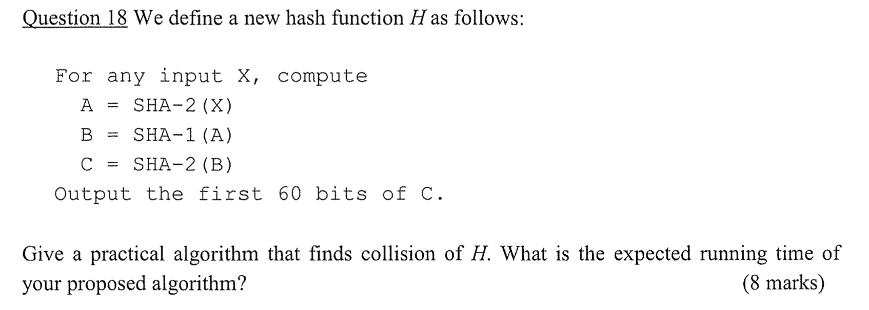

3 * 2 ^ 30 at least 0.5 probability



1. What the subject has; Something you have: Smartcard Mobile phone

2. What the subject knows; Something you know: Password

3. What the subject is; Something you are: Biometrics, Fingerprint, Face, Iris

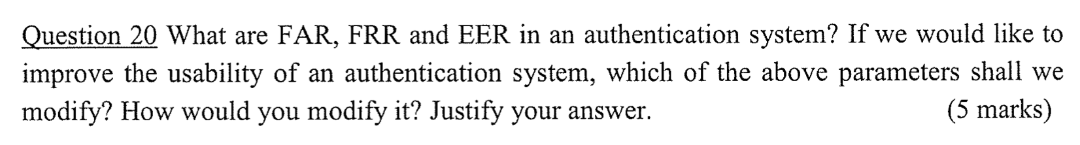

false accept rate; false reject rate; There exists a threshold in which FAR = FRR and in that case the rate is said to be at Equal Error Rate (EER). If we want to improve the usability, we can make the FRR lower. Then the users will have less chance to be wrongly rejected.

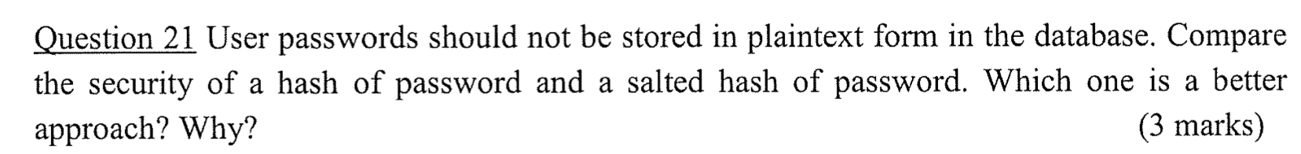

Salted hash of password; 1. It can slow down the attacker.

2. Hash once and check against all users’ hash vs hash once for one user at a time. Comparing to the case of storing the hash of password directly, the attacker can hash and check once for one user at a time only, instead of hashing once and checking against all users’ hashes. Hence, salt slows down the attacker.



Google Sign-In uses OAuth protocol / Microsoft



The primary difference between a blockchain and a database is centralization. While all records secured on a database are centralized, each participant on a blockchain has a secured copy of all records and all changes so each user can view the provenance of the data.

Integrity and availability.



“Convince someone that a given statement is in the language without revealing the witness”. It can be used to convince others that you are the owner of a public key. In other words, to let you know “I am the owner of a public key”, without giving you my private key.

**2017-2018-2**

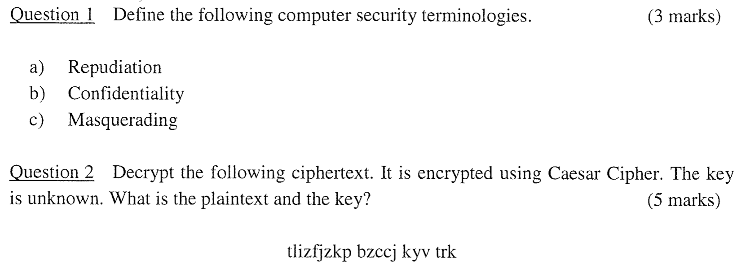

跳过

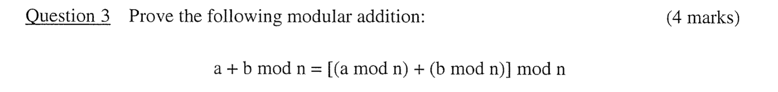

https://www.khanacademy.org/computing/computer-science/cryptography/modarithmetic/a/modular-addition-and-subtraction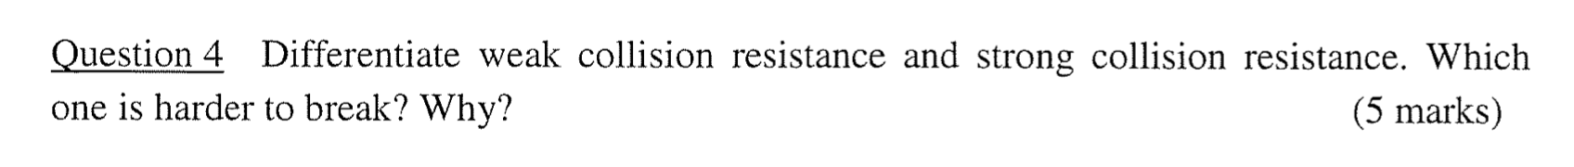

given x is infeasible to find y s.t. H(y) = H(x) › weak collision resistance

is infeasible to find any x, y s.t. H(y) = H(x) › strong collision resistance



作业题目



?

Authentication of the server.

Confidentiality of the communication channel.

Message integrity of the communication channel.

TLS Handshake The client sends a “Client hello” message to the server, along with the client's random value and supported cipher suites (e.g., TLS_ECDHE_RSA_WITH_AES_256_CBC_SHA384).



n = 31 * 59 phi_n = 30 * 58 = 1740 d = 911

M = C ^ d mod n = 311

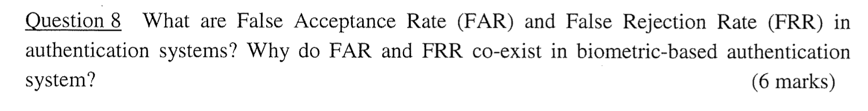

The measurements of biometric features as well as the features themselves are subject to statistical fluctuations. Therefore, every biometric recognition system has a built-in acceptance threshold.

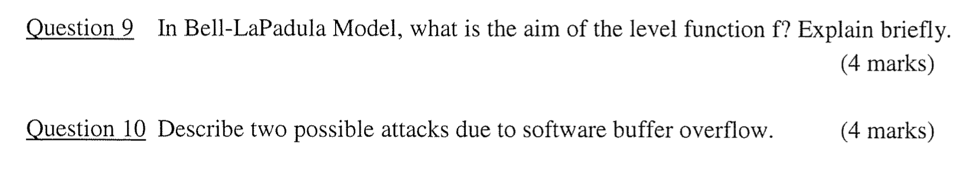

??



Non-persistent: Malicious code is executed by the victim’s browser, and the payload is not stored anywhere; instead, it is returned as part of the response HTML that the server sends

Persistent: The payload is saved in a secondary storage (database)

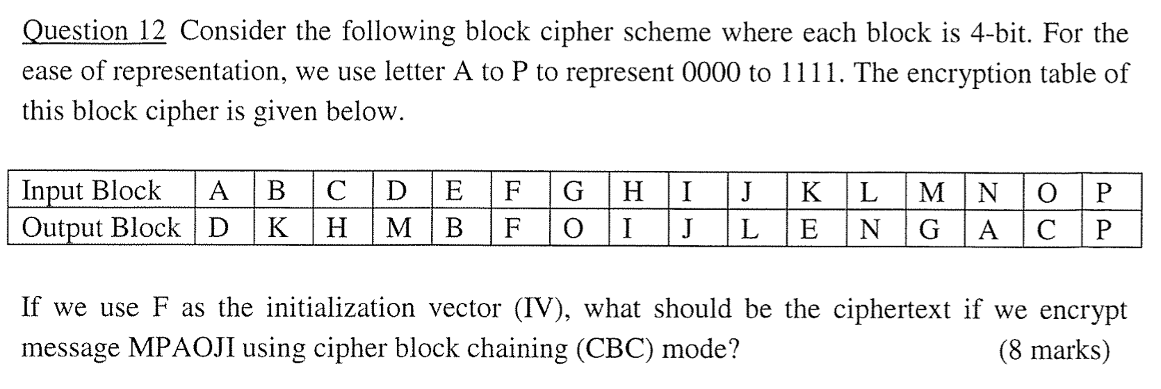

??

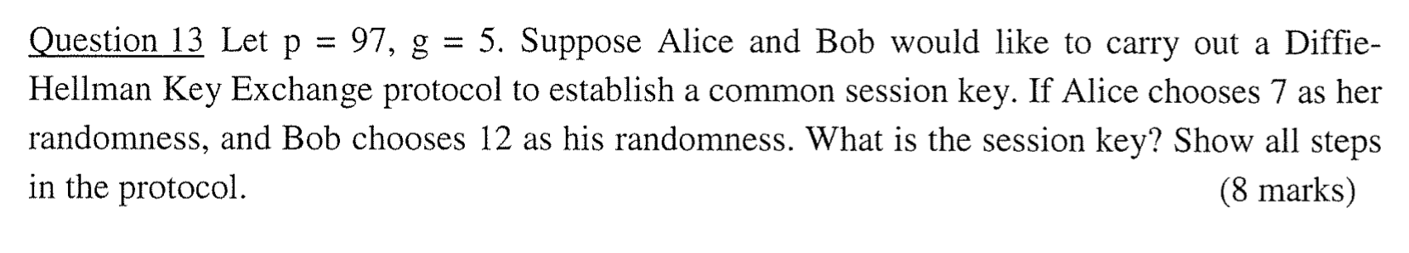

Alice: 5 ^ 7 mod 97 = 40 Send to Bob

Bob: 5 ^ 12 mod 97 = 64 Send to Alice

Alice: 64 ^ 7 mod 97 = 47

Bob: 40 ^ 12 mod 97 = 47

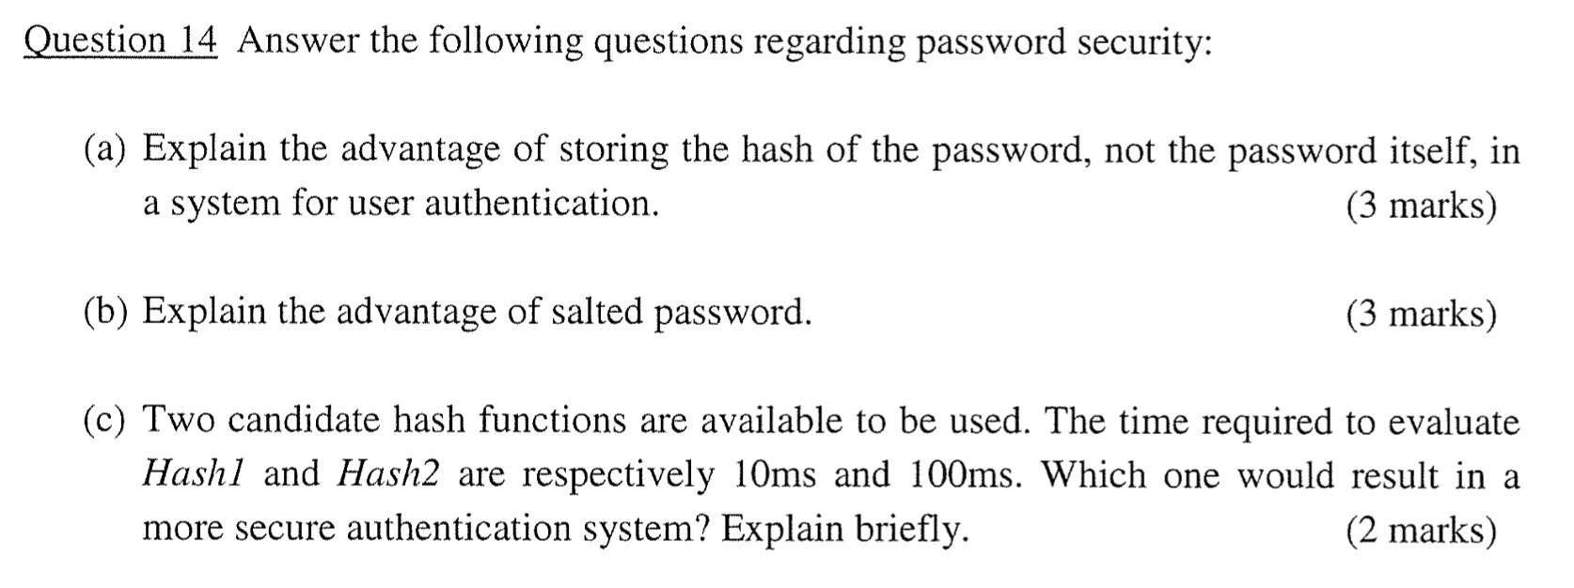

If the passwords are leaked, the hacker can know all the passwords instantly.

Salted hash of password; 1. It can slow down the attacker.

2. Hash once and check against all users’ hash vs hash once for one user at a time. Comparing to the case of storing the hash of password directly, the attacker can hash and check once for one user at a time only, instead of hashing once and checking against all users’ hashes. Hence, salt slows down the attacker.

Hash2;

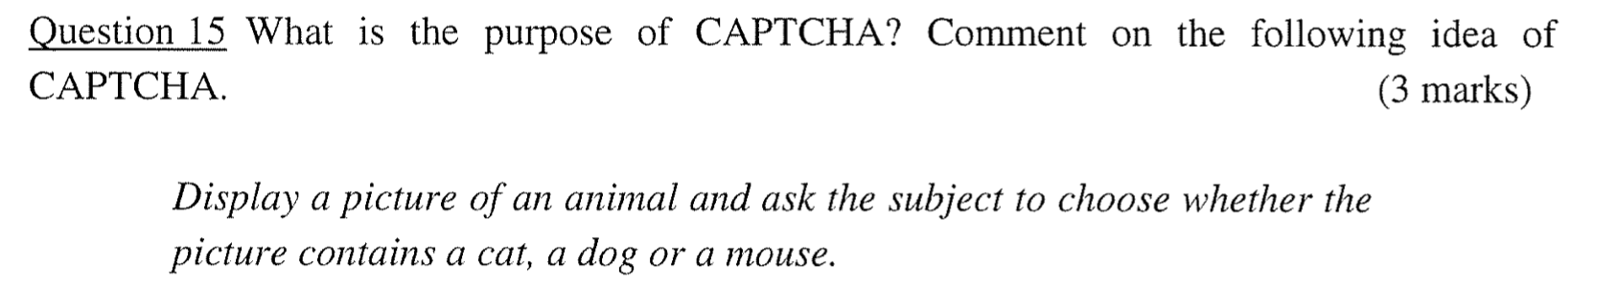

A CAPTCHA is a program that protects websites against bots by generating and grading tests that humans can pass but current computer programs cannot.



Strong Password Protocols

› EKE is one example of Strong Password Protocols

– Secure against eavesdropper

› No available plaintext-ciphertext pairs for dictionary attack.

– Secure against impersonation

› Malice must guess the correct W in order to impersonate Bob in the first message flow.

› So it achieves mutual authentication

– Bob must know W to encrypt PKE(K) correctly.

– Alice must know W (and her private key) to recover K and use K to encrypt RA correctly



Can be online and off-line

Payer anonymity

Need not reveal payer’s identity

Can pay for any value (up to certain limit)

Easy to convert from traditional bank notational money

Infeasible to forge

Payer untraceable by PSP (Payment Service Provider)



Firstly, everyone in the system has a full copy and the records cannot be simply changed. Second, each block contains the specific hash value of the previous block. Changing any record is not possible without changing the hash value. All in all, by design, blockchains are inherently resistant to the modification of data. Blockchain ledgers are immutable meaning that if data addition or transaction has been made, it cannot be edited or deleted.



WannaCry uses a combination of different encryption algorithms to encrypt files and keys. It uses both the Advanced Encryption Standard (AES) and the Rivest-Shamir-Adleman (RSA) algorithm in the attack. AES is a symmetric-key encryption algorithm, while RSA is an asymmetric-key (or public key) encryption algorithm. It combines the computational efficient symmetric-key cryptosystem and the convenience in key management in public-key cryptosystem.

**2017-2018-1**

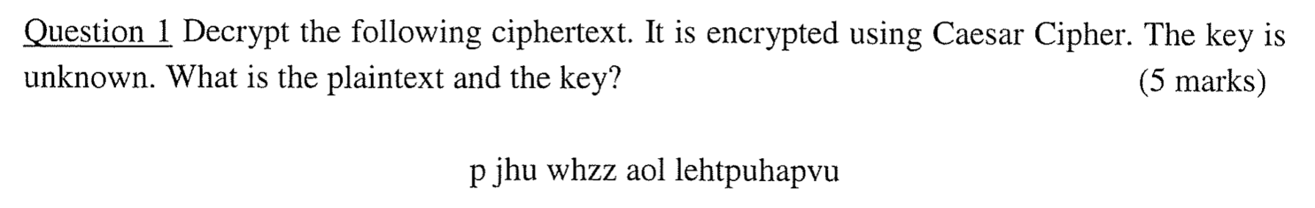

i can pass the examination



Shannon suggested combining elements

to obtain: 1. Diffusion: dissipates statistical structure of plaintext over bulk of ciphertext 2. Confusion: makes relationship between ciphertext and key as complex as possible



The main advantage of the CFB mode is that, since it doesn't use a decryption algorithm, it is generally faster than the CBC mode. CFB encryption is also non-deterministic, which means it does not reveal any patterns the plaintext may have. The disadvantages of CFB are identical to those of the CBC mode.

the block cipher is only ever used in the encrypting direction, and the message does not need to be padded to a multiple of the cipher block size (though ciphertext stealing can also be used for CBC mode to make padding unnecessary).



pq -p -q + 1 = Known; pq known; p + q is known;

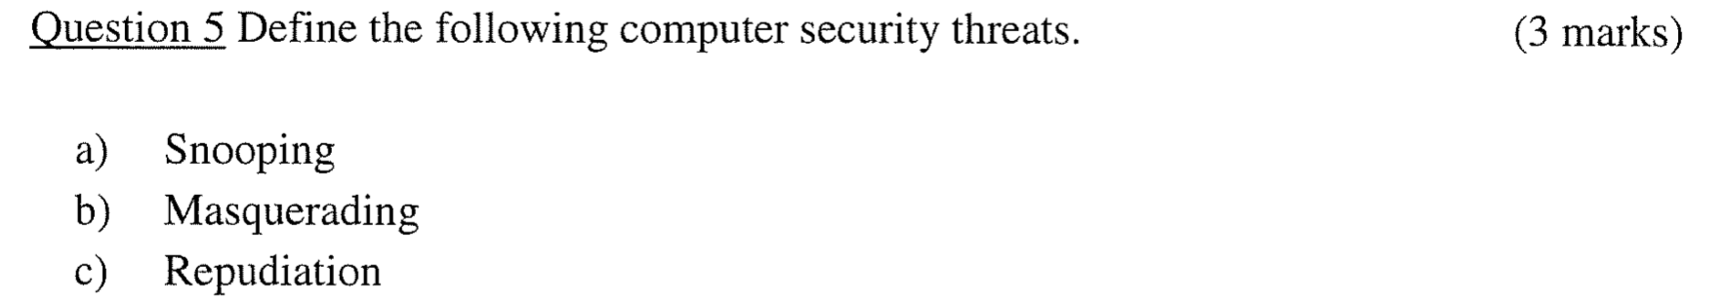

Snooping

– Unauthorized interception of data – E.g., Passive wiretapping

Masquerading or Spoofing

– Impersonation of one entity by another

Repudiation of origin

– A false denial that an entity sent or created something



Steganography

› Hides existence of message

– Using invisible ink

– Using only a subset of letters/words in a longer message marked in some way

– Hiding in LSB in graphic image or sound file



没讲

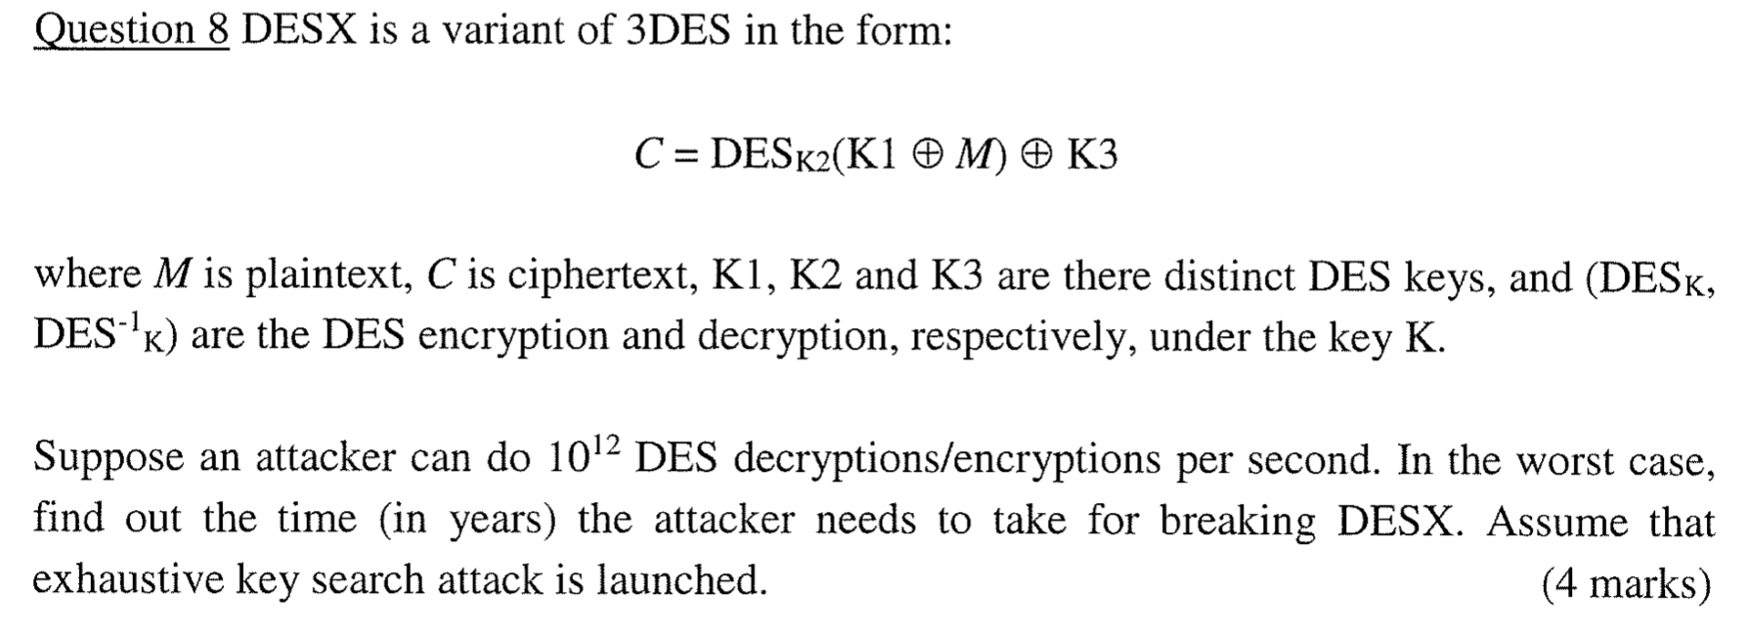

1.1 * 10 ^ 31



Virus replicates itself. Worms are also replicates itself. But Trojan horse does not replicate itself.

Virus can’t be controlled by remote.

Worms can be controlled by remote. Like worms, Trojan horse can also be controlled by remote.



重复

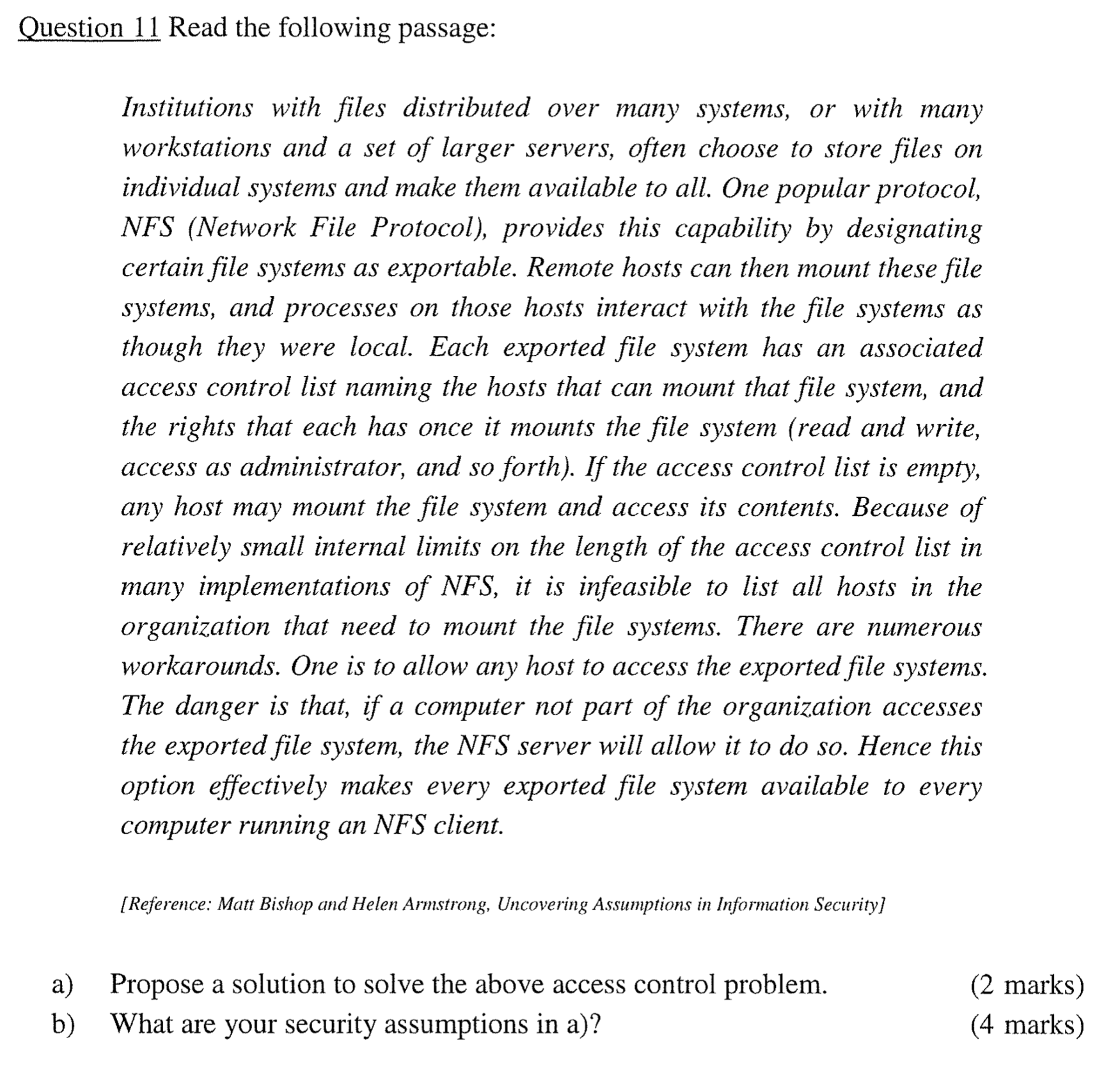

Many institutions with internal networks use firewalls to limit access to their network. That ameliorates the threat of an external host mounting the internal file systems, as the firewall can simply block requests to the NFS servers from the outside network. So, assuming the security policy of the institution disallows external mounting of internal NFS file systems, the firewall’s being configured to disallow such communications appears to satisfy the policy.

Now, what assumptions are being made? One is that the firewall is configured correctly and that the implementation supports the given configuration. This involves co-ordination among the system managers running NFS and the system managers running the firewall. In particular, the former must understand that the firewall is blocking NFS messages, and the latter must understand that the internal servers have no access control protection. As Winkler amply demonstrates [Winkler 1997], coordination problems lead to security problems. Less obvious ones are the assumptions that the firewall and NFS servers are implemented correctly. These assumptions involve trusting the vendor, and most sites have no choice other

than doing so. Perhaps the most subtle assumption is that the firewall intercepts all traffic

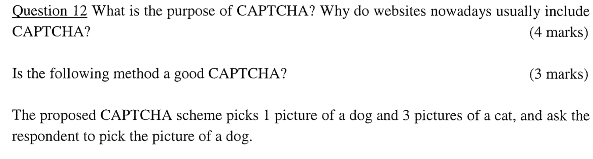



没讲吧

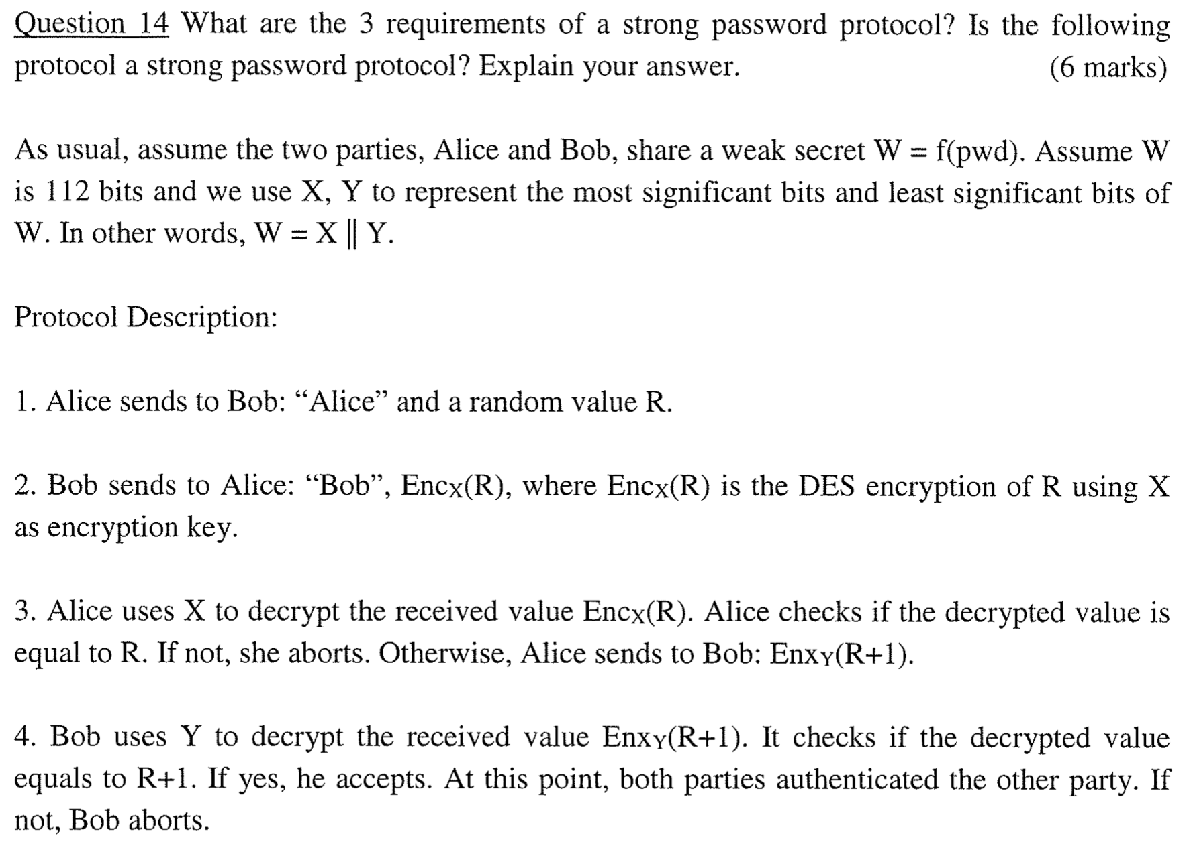

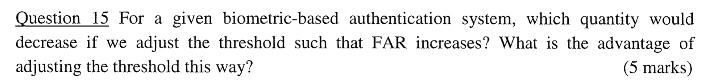

If False accept rate increase, then the usability will decrease, but it will be more secure..

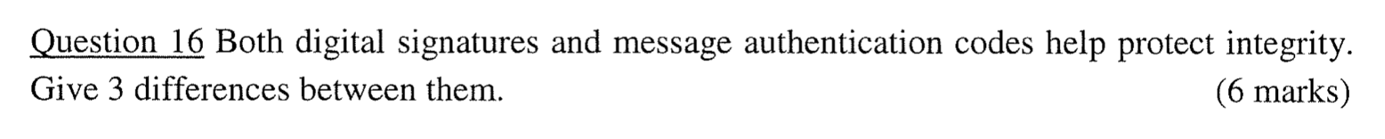

?

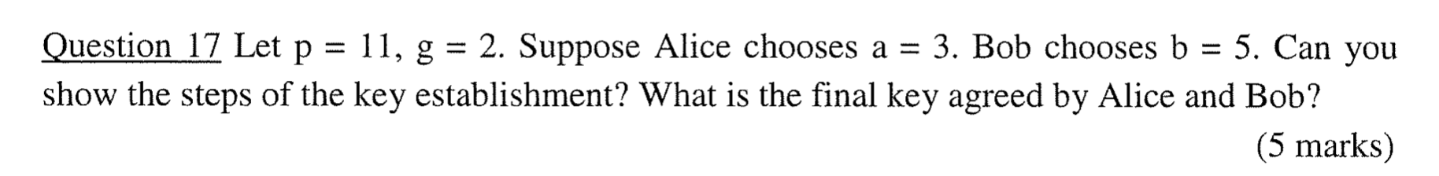

Alice: 2 ^ 3 mod 11 = 8 Send to Bob

Bob: 2 ^ 5 mod 11 = 10 Send to Alice

Alice: 10 ^ 3 mod 11 = 10

Bob: 8 ^ 5 mod 11 = 10

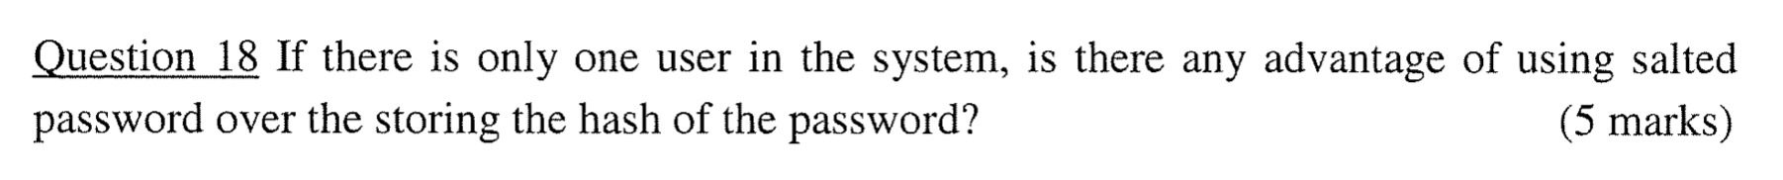

Yes, salting passwords is always a good idea. It doesn't matter how many users there are. If an attacker gets hold of your database and your hashes are not salted, he has an enormous advantage, because there might be rainbow tables and other techniques to get a match for the hash values just obtained. Salted passwords on the other hand do provide security, because the salt is not known to the attacker in advance.

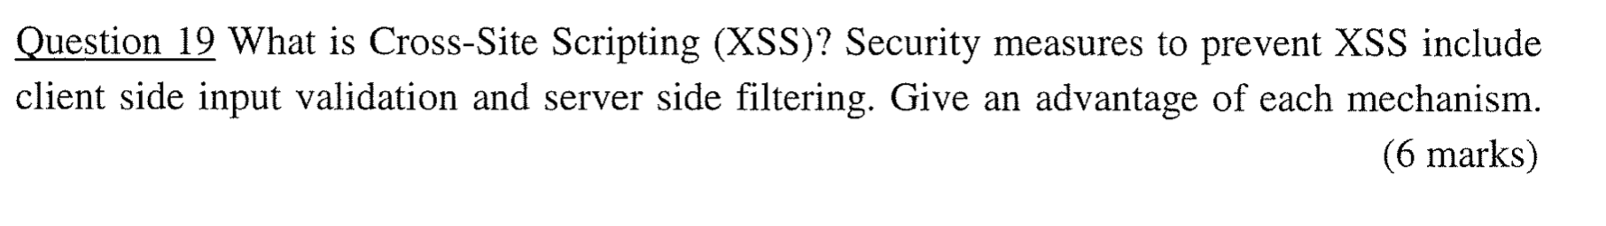

Client-side advantage: No load to the server as the browser is performing the input validation checks. Response from client side filters are faster since they reside in the user’s browser itself.

Server-side advantage: Server-side filters are difficult to tamper or bypass. Provide better security to data.

其他：

Asymmetric cryptosystems typically make use of modular exponentiations (e.g. RSA). This may take considerable computational time if the plaintext is very long. For example, using the long multiplication with exponentiation by squaring, it requires O(n2 *k) where n is the length of plaintext and k is the number of bit of the exponent (key).

Symmetric cryptosystems typically use substitutions and permutations (e.g. DES), which requires relatively less time to compute.